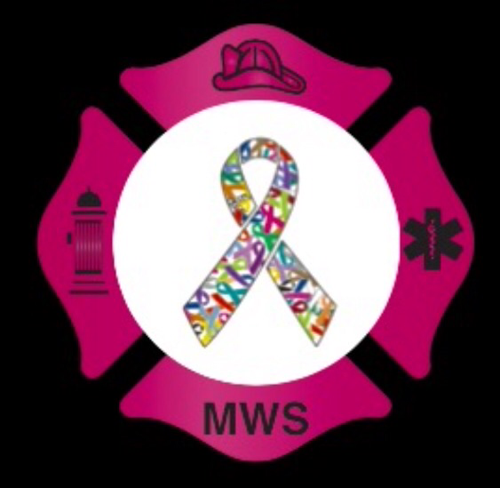

Schaumburg Professional Firefighter’s Association “2020 Corporate Pink Tie Ball Sponsorship”

The Schaumburg Professional Firefighter’s Association’s: Firefighters Fighting Cancer Committee’s “Corporate Sponsorship” program is asking your company to graciously consider choosing from one of our five sponsorship levels, thus guaranteeing your company an allotted amount of advertising, outreach and diplomacy based on the donation amount. All levels are incentive based and guarantee copious amounts of advertising before, during and after the event’s culmination. This monetary donation will not only fundraise to help combat cancer awareness, fund cancer research and assist with those currently undergoing treatment, but your company will be publicized as one of the few, trying to help bring an end to this vicious disease! One Hundred percent of net proceeds raised from our “Corporate Pink Tie Ball Sponsorship” will be donated to the National Cancer Research Institute, specifically earmarked for cancer research, benefiting those currently being treated for cancer. Federal Tax ID #36-3972831/ Illinois Department of Revenue E9923-1212-01).

Schaumburg Professional Firefighters Association’s: Firefighters Fighting Cancer Committee guarantees claims stated below, based on individual’s sponsorship package:

PINK LEVEL SPONSORSHIP/TOP LEVEL ($6,000+ USD):
The PINK level sponsorship is our highest, most prestigious level of overall event sponsorship. Essentially, if your company chooses to be a PINK level sponsor the marketing, advertising and signage privileges are practically endless. Also, if a PINK level sponsor comes up with a marketing/sales idea, an idea that is within a respectful limit, the marketing/sales idea can be discussed and agreed upon by the committee chair.

■ Logo Slot on the front of the Schaumburg Professional Firefighter’s: 2019 Pink Tie Ball’s event invitation (to be mailed out to approximately 700 people/attendees)
■ Step and Repeat Banner: located behind the “Pink Carpet,” behind the couples as they take their couple’s photo at the event. A step and repeat banner is a backdrop that features your company logo, name or individual design that alternate and repeat throughout an expansive printing area. At the 2018 PTB all 500 + guests took, at minimum one picture in front of our corporate sponsor “step and repeat banner.” A huge advertising success!
■ Logo Slot on the front of the PTB 2019 Poster: Schaumburg Professional Firefighter’s: 2019 Pink Tie Ball’s event poster (approximately 200 printed and posted at various locations around the Village of Schaumburg, businesses across The Chicagoland area SFD fire stations, other fire departments, training facilities and public locations/buildings.
■ Individualized Company Banner to be placed in the ballroom at the 2019 Pink Tie Ball, centrally located so that it is the first and largest banner to meet the eye. PINK level sponsor banners will be larger than other levels and will be strategically placed at the front of the stage/podium.
■ Website advertisement space, the space that will be allotted for our PINK level sponsors will be a whole page strictly designated for our corporate sponsor. The top level sponsor logo will also be located on each of he Pink Tie Website pages, but in a more attractive, eye catching area on Pink Tie Ball website. It will be the best space available on our website. Our PTB website is visited not only by all 500+ people that sign up for the event online, but those who donate and those that order merchandise online. Premium spots will also be available on our Face book page for our PINK level sponsors.
■Video option: Your company has the opportunity to run an advertisement, or video that can be running continuously during the cocktail hours throughout the evening (video must be on mute).
■ Speech at our Pink Tie Ball: The Pink level sponsor will be allotted a space to have one keynote speaker make a speech throughout dinner(approximately three minutes), explaining to our guests why your company has the same passion we do regarding finding the cure for cancer, and what it means to you and your corporation.
■ Company Booth: Your company will have the option to directly interact with attendees, engaging and offering any type of handouts, information and contact guidelines you may wish at your own personal booth. Tables provided on site.
■ Your sponsorship includes everything listed within this level, as well as everything listed below in the subsequent levels. EXCLUDING THE INVITATION ENVELOPE INCENTIVE.

PLATINUM LEVEL SPONSORSHIP ($5,000 USD):
The PLATINUM level sponsorship includes an array of different advertising, marketing and sales opportunities that are high visibility, and high impact to many people, not only seen by guests at the ball, but by many people outside of the event.
■ Logo slot on the 2019 Pink Tie Ball invitation envelop. Your company logo will be strategically placed on the back (folding area) of our specially designed envelope. Our event invitations are mailed out to approximately 500 recipients.
■ Corporate Table: Your company will be allowed a corporate sponsored table at the event, allowing for a group of ten, whomever you prefer to sit at your reserved table at the 2019 Pink Tie Ball. Your table will be equipped with signage, place settings and will be located in a premium, high visible spot at the PTB.
■Logo advertised on our place cards, cards will have each and every individual guest’s name on it and will set out at each table setting. This level sponsorship will allow your company’s logo to be placed either on the back or on the bottom of the place card, your choice.
■ Company Banner, banner will be a 3x5 foot banner located in the hallway of the Pink Tie Ball.
■ Website Advertisement/logo space, space allotted for the Platinum level sponsorship will be on the Pink Tie Ball web page where people order their tickets, order their T-shirts and make donations.
■ Company Expo Table, company has the opportunity to advertise, meet people and explain their passion for finding a cure, along with their company’s ideals and offerings. This table should be a combination of pink giveaways/ pink advertisements, themed giveaways that will not alienate our guests, but let them know who you are, and that you want to find a cure and raise awareness at the same time.
■ Your sponsorship includes everything listed within this level, as well as an option for having everything listed below in the subsequent levels.

SILVER LEVEL SPONSORSHIP ($3,500 USD):
This level sponsorship is a sponsorship that allows the company to advertise, market their products and reach our guests (in attendance) in a more intimate way. This level allows corporations to have a presence at the 2019 Pink Tie Ball, reach our guests, while not having to be physically present in order to see a ROI for their sponsorship.
■ Corporate sponsored table at event. This table will be labeled, marketed as the “so n’ so” table, equipped with signage and table setting advertisements. However, this table will be merely a sponsorship for a table, the seats will be sold and PTB 2019 guests will be sitting at your company table.
■ Company will have the option to put an insert, sample product or advertisement in our Platinum Level Ticket gift baskets (these are gift baskets that are given out to our guests that order the top tier ticket to the Pink Tie Ball
■ Website Advertisement/logo space, space allotted for the SILVER level sponsorship will be on the Pink Tie Ball web page where people order their tickets, order their T-shirts and make donations.
■ Shared Banner Space, Silver level sponsorship will be allowed to be on three different banners, but will have to share the space with BLACK level sponsors as well. The company’s logo will be bigger and therefore more visible if they are a SILVER level sponsor, compared to a black level sponsor.
■ Coupon or advertisement insert for a place settings, gift bags are to be placed at each individual place setting at the Pink Tie Ball. Each plate, each guest will have a small pink gift bag/goody bag to take home with them from the event. This level sponsorship allows your company to put an insert of your choice to be placed in the gift bag.
■ Your sponsorship includes everything listed within this level, as well as an option for having everything listed below in the subsequent levels.

BLACK LEVEL SPONSORSHIP ($2,000 USD):
The Pink Tie Ball Firefighter’s Fighting Cancer Committee has created this level sponsorship for companies to have some type of direct and to the point advertisement, where they can reach out to all of our 500+ guests in a variety of ways.
■ Company logo to be placed on our raffle signs, silent auction signs and 50/50 signs. Your company logo can be the placed on the bottom of all of our raffle signs. The past two years we had over two hundred different prizes and three hundred different signs printed off for the event itself.
■ Coupon or advertisement insert for a place setting gift bags, gift bags are to be placed at each individual place setting at the Pink Tie Ball. Each plate, each guest will have a small pink gift bag/goody bag to take home with them from the event. This level sponsorship allows your company to put an insert of your choice to be placed in the gift bag.
■ Shared banner, (3 X 9 foot banner) your company will be allowed to share a banner with some of our silver level sponsors. Your company’s logo will be large and highly visible, but will not be quite as large as our SILVER level sponsors.
■ Website Advertisement/logo space, space allotted for the BLACK level sponsorship will be on the Pink Tie Ball web page where people order their tickets, order their T-shirts and make donations.
■Business cards, pamphlets, and general advertisement area. This level sponsorship allows the company to set up a high class advertisement expo table, on a high boy style table.
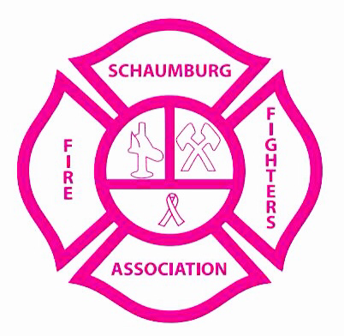
■ Your sponsorship includes everything listed within this level, any other requests shall be discussed with committee and inserted into the Corporate Sponsorship contract, under special provisions.

